BACKGROUND VERIFICATION FORM – Zediant Technologies
Please provide complete and correct information with utmost attention, all these shall be verified by authorized representatives.
Personal Information
Name | Suparna Modak | Employee Code | ZT0031
Gender | Female | DOB | 03/02/1999
Designation | Junior Software Quality Analyst | Joining Date | 4th April 2023
Email | suparna.modak@zediant.com | Mobile | 7001171516
Father’s Name | Partha Modak | Nationality | Indian

Residential Address
Current Address
City | Purba Bardhaman | State | West Bengal
Pincode | 713422 | Staying From | Bijur
Permanent Address
City | Purba Bardhaman | State | West Bengal
Pincode | 713422 | Staying From | Bijur

Educational Information (Highest Certification)
College | Saroj Mohan Institute Of Technology | Group
Major Subject | Electronics and communication Engineering. | Location | Guptipara, Hooghly.
From Date | 08/08/2016 | To Date | 20/07/2020
Course Type | Regular | Part Time
Certificate Submitted

Employment History
Current Employer
Company Name | Zediant Technologies Pvt. Ltd. | Location | Bidhannagar, Kolkata.
Employee ID | ZT0031 | Designation | Junior Software Quality Analyst
From Date | 04/04/2023 | To Date
Work Type | Regular | Part Time | Contract | Department | Quality Assurance
Reporting Manager |  | Designation
Mobile |  | Email
Employment Proof Document | - Experience Certificate  - Relieving Letter  - Payslips  - Any Other
Previous Employer (1)
Company Name | Techolution India Pvt Ltd | Location | Hyderabad
Employee ID | TECH01693 | Designation | Associate QA Engineer
From Date | 04/11/2022 | To Date | 17/03/2023
Work Type | Regular | Part Time | Contract | Department | Quality Assurance
Reporting Manager |  | Designation
Mobile |  | Email
Employment Proof Document | - Experience Certificate  - Relieving Letter  - Payslips  - Any Other
Previous Employer (2)
Company Name |  | Location
Employee ID |  | Designation
From Date |  | To Date
Work Type | Regular | Part Time | Contract | Department
Reporting Manager |  | Designation
Mobile |  | Email
Employment Proof Document | - Experience Certificate  - Relieving Letter  - Payslips  - Any Other
Previous Employer (3)
Company Name |  | Location
Employee ID |  | Designation
From Date |  | To Date
Work Type | Regular | Part Time | Contract | Department
Reporting Manager |  | Designation
Mobile |  | Email
Employment Proof Document | - Experience Certificate  - Relieving Letter  - Payslips  - Any Other

DECLARATION

I hereby declare that all the information provided here is true and complete to the best of my knowledge and belief. I promise to extend total cooperation and provide relevant documents if required.

Place: Kolkata 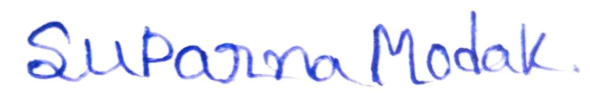
Date:16/09/2024 Applicant’s Signature

